**MEC102**

Introduction to Engineering Design

Design project

On

Smart Medical Kit

Submitted by

Mukesh Prasanna

Dashti Krishna Venkat Chowdary

Adhavan K

Introduction

A medical kit is a container to organize medication doses for a certain time. It’s also called a pill container or pill case. Using a medical kit is very helpful if you need to take a few different medications. It will help you avoid missing doses of your medications.

Medical kit is frequently used in homes of old-aged people. Old-aged people need to take different medicines daily. But most often they forget to take medicines. They need assistance to take medicines properly.

People can’t go to the doctor for small complications like fever, cold, etc. They need some assistance in taking proper medicines for small complications as mentioned above.

Medical kits can be opened by kids and there are risks that kids can take when parents are not around.

Hence, in situations like the above, using current-day technology, there are multiple ways to rectify the above problems.

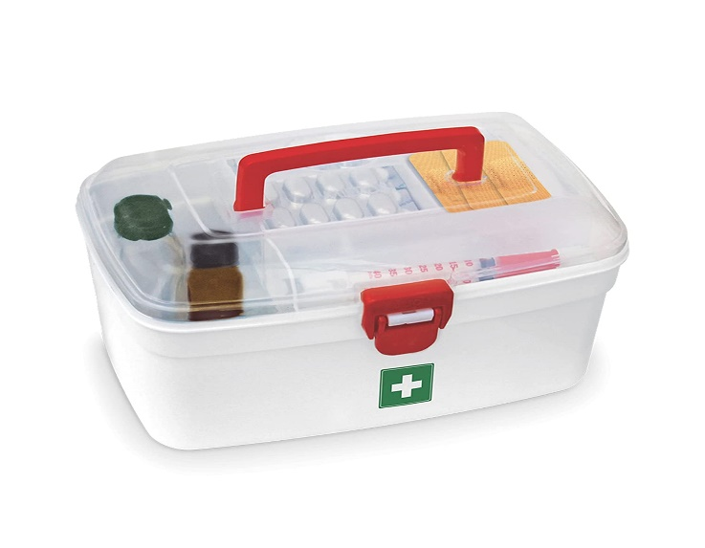 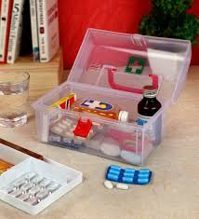

**Objective**

The main objective of this project is:

* To design different ways to maintain the hygiene of medicines.
* To guide people in taking medicines for small complications like fever, cold, etc.
* to reduce the risk of kids reaching the medicines.
* To remind every day to take medicines according to time table.

**Problem Statements**

* A regular medical box is at high risk of being approached by kids.
* Sterility of medicines in medical box.
* Old people forget to take medicines.
* People can’t visit a doctor for small problems.

**Need Statements**

* Sterile the medicine kit after use.
* Avoid kids from taking medicines from the kit.
* Remind people to take medicines on time.
* Suggest and provide medicines for small diseases like cold, fever, etc.

**User Requirements**

* It should remind us to take medicines on time.
* It should order required medicines on time.
* It should be easily accessible.
* It should require minimal repairs.
* The colour of the case should meet the user’s needs.

**Functions**

* Protection against physical contaminations from insects and lizards.
* UV light emitters, preferably LEDs, are fixed into the device to keep the brush sterile.
* Built-in touch screen to perform various functions.
* Large compartment to store medicines.
* Medicines are scanned and stored according to the kit’s database.
* Suggests and provides required medicines according to the symptoms of the disease.
* Reminds and provides medicines according to the prescription given by the doctor.
* Links to home smart devices like Google Home and Alexa and orders required medicines.

**Constraints**

* Availability of materials.
* Price should be affordable and the device shouldn’t be bulky.
* Less risk of breakage and damage should be there.
* Battery life should be good, if not coupled with a power source.
* Case materials should filter out UV from reaching out of the box.
* The case should necessarily be water-resistant and dust resistant.

**Target Specifications**

* **Battery life:** 1 week (full charge)
* **Battery Charge Time:** 30-45 minutes (0-100%)
* **Case Strength:** strong enough to withstand 1000 drops.
* **Resistance Towards:** Dust, Drop, Water, High voltage, UV light leakage.
* **UV Intensity:** 100-280 nm wavelengths.
* **UV Sterilization duration:** 10-15 minutes.

**Black Box**

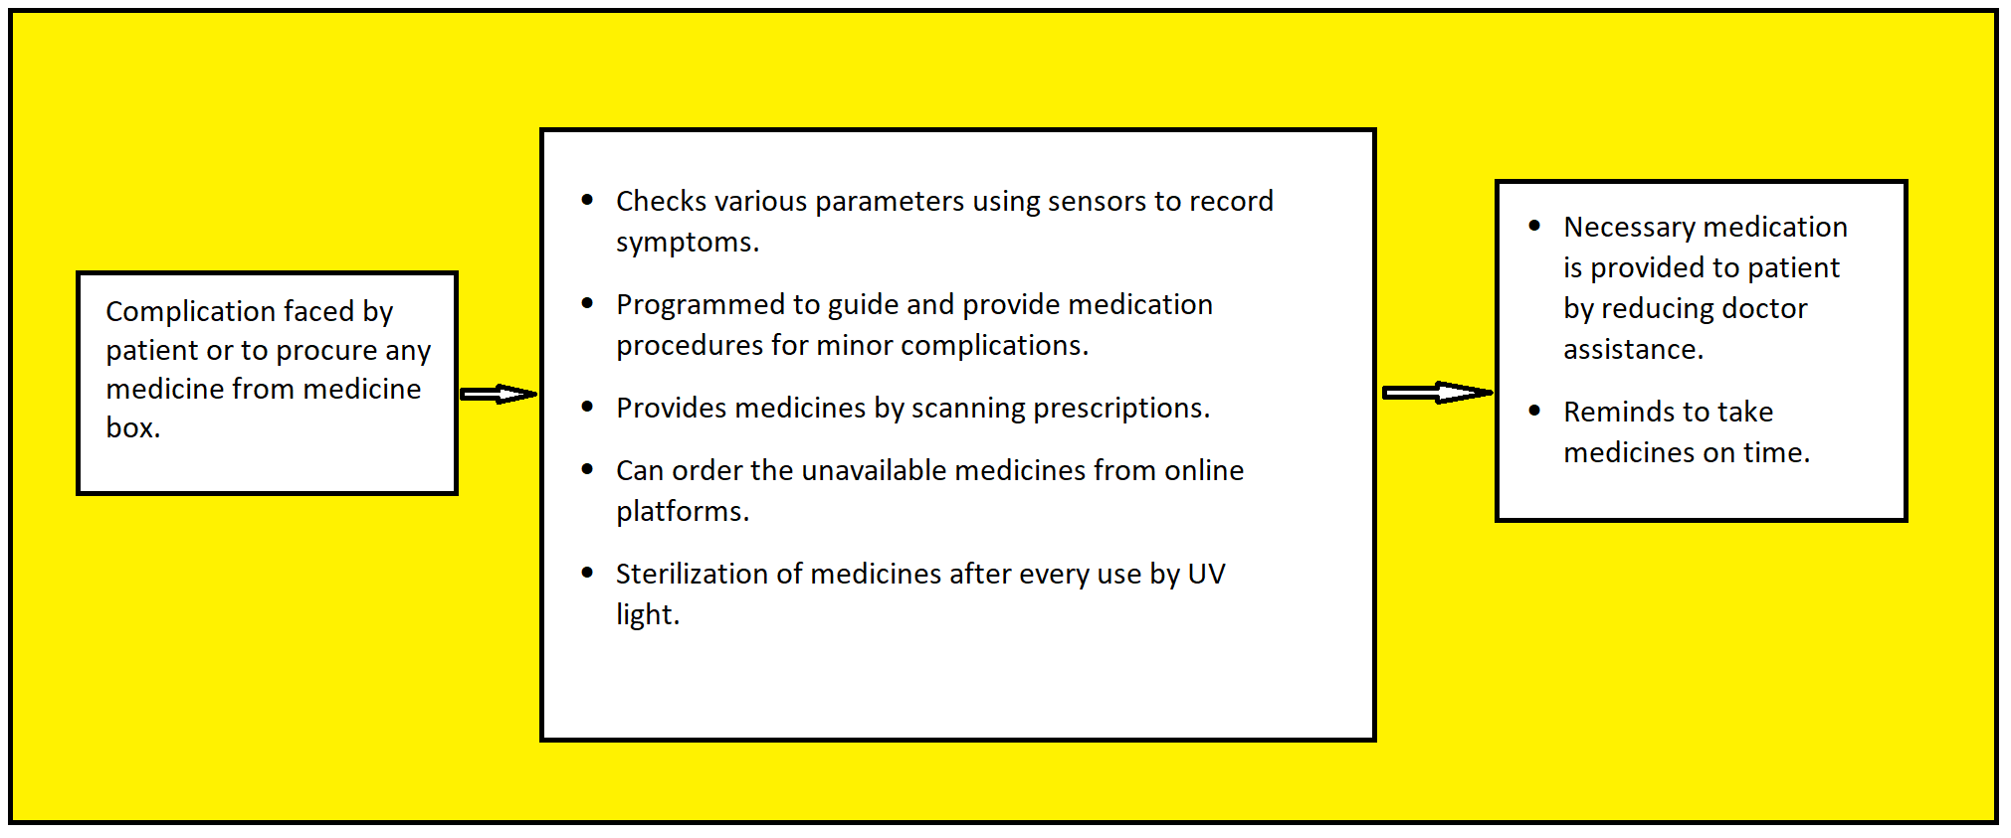

**Kano’s Model**

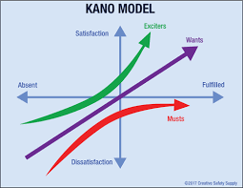

**Musts:**

* To process various kinds of basic medicines and first aid equipment.
* A large enough box to store various kinds of medicines.

**Wants:**

* Ability to scan prescriptions and remind to take medicines on time.
* Ability to sterilize medicines after every use.

**Exciters:**

* Ability to understand symptoms of regular complications and provide medicines to treat them.
* Ability to order required medicines online.

**Morphological Chart**

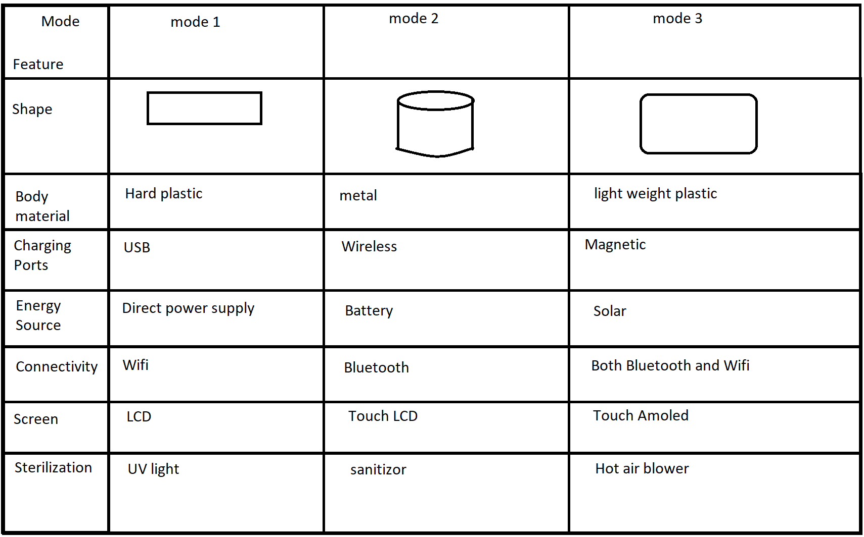

**Conceptual design**

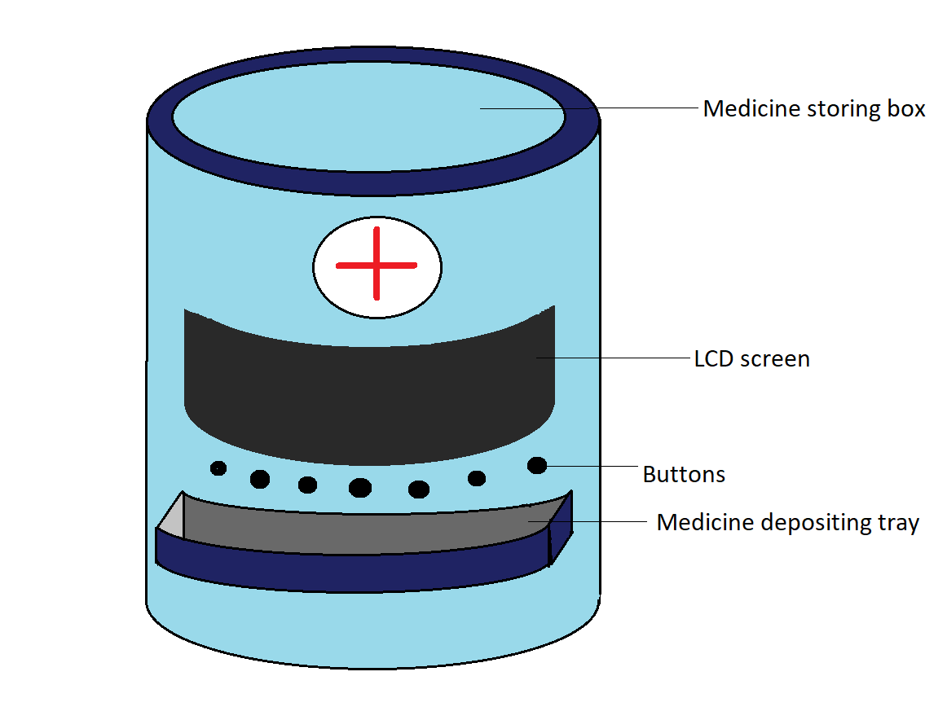

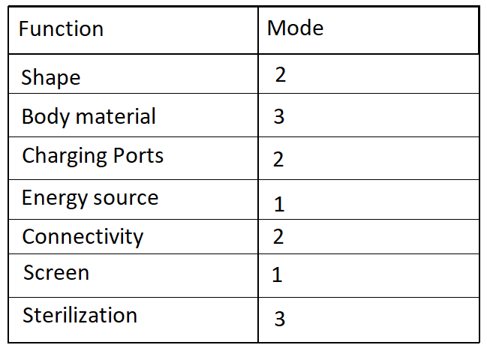

**Final Design**

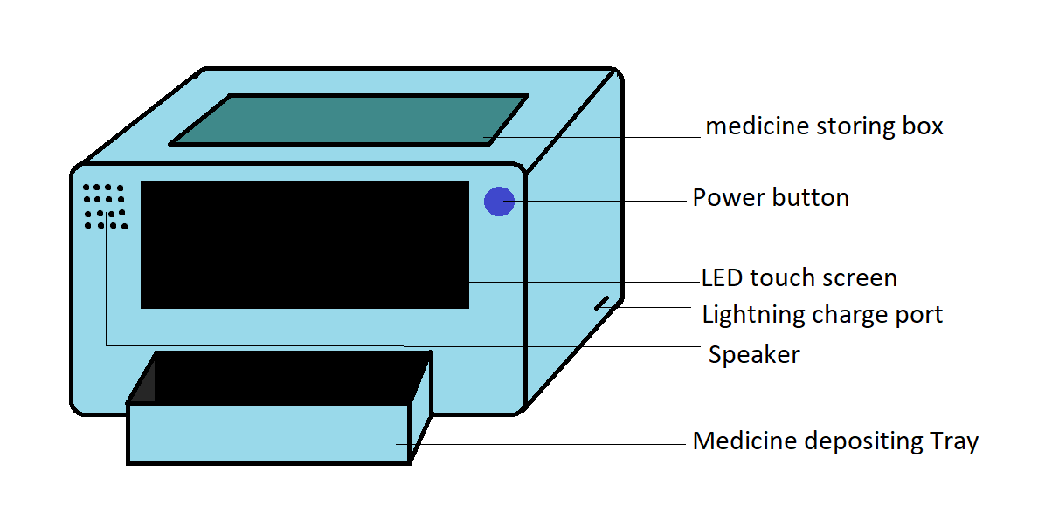

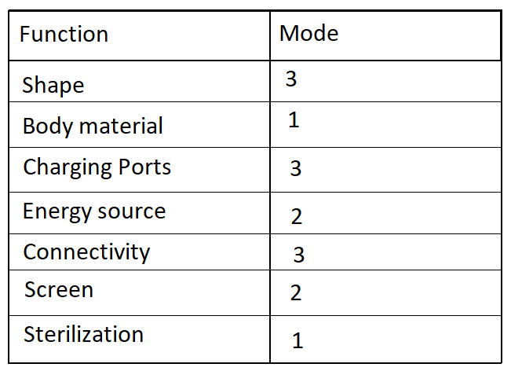

**Morphological Chart for Final Design**

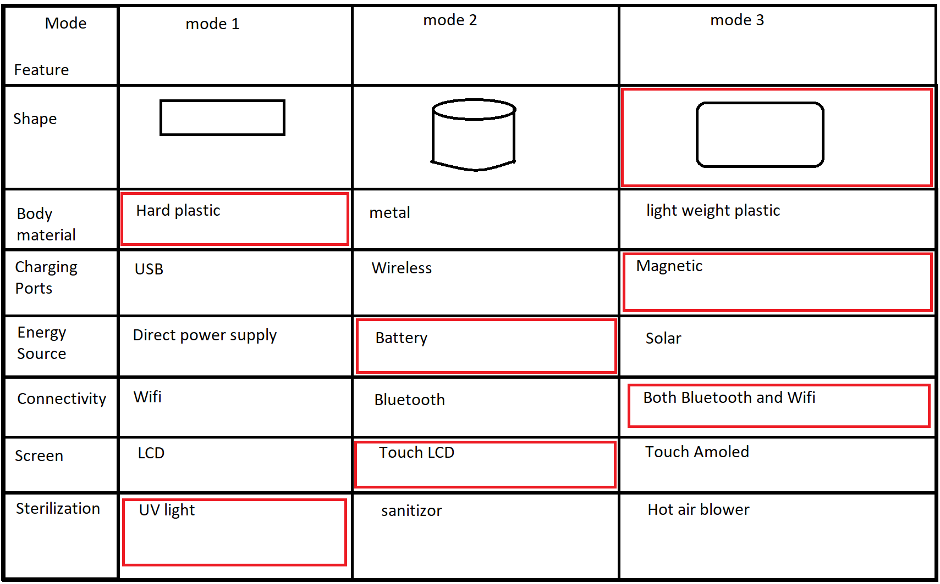

**Conclusion**

This final design is better than the sample design because the container box is big enough for more quantity of medicines. The final product has a touch LCD screen which is easy to operate. UV sterilization is absent in the sample product. The sample product can’t withstand more drops. All the features in this design are aimed at maximum efficiency and comfort for the user. Thus, solving the problem and satisfying the customer’s needs.